Câu 1

def test_nhi_phan(a):

    if(a == '0000' or a== '0001' or a == '0010' or a== '0011' or a == '0100' or a== '0101' or

    a == '0110' or a== '0111' or  a == '1001'):

        return True

    else:

        return False

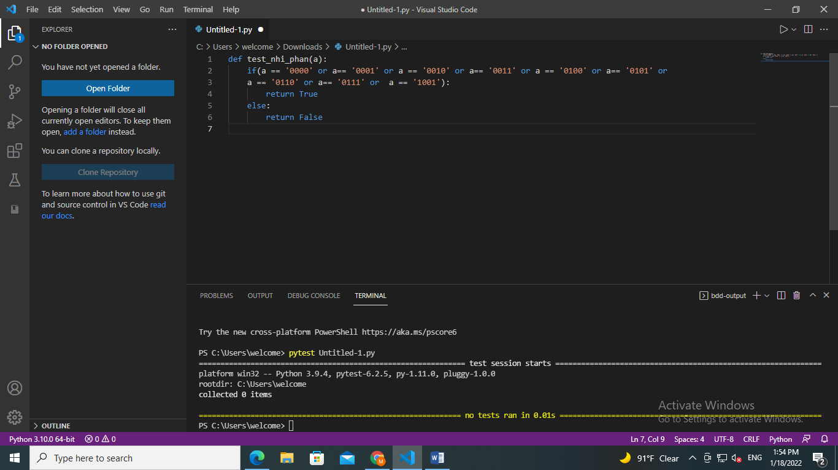

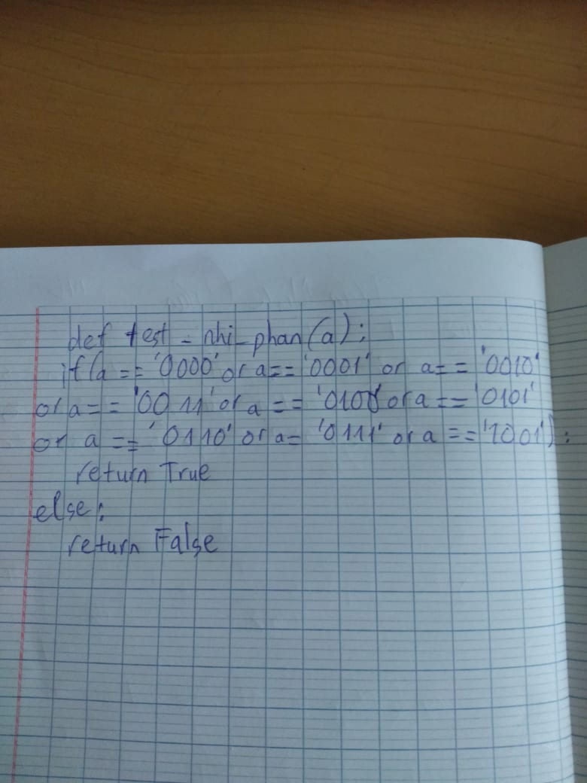

Câu 3b

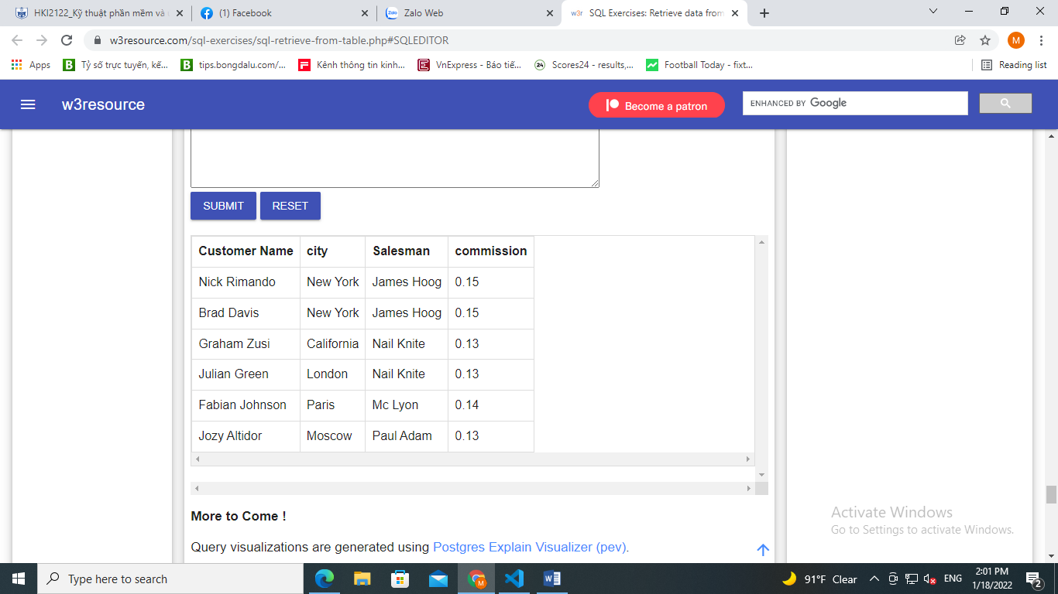

SELECT a.cust_name AS "Customer Name",

a.city, b.name AS "Salesman", b.commission

FROM customer a

INNER JOIN salesman b

ON a.salesman_id=b.salesman_id

WHERE b.commission>.12;

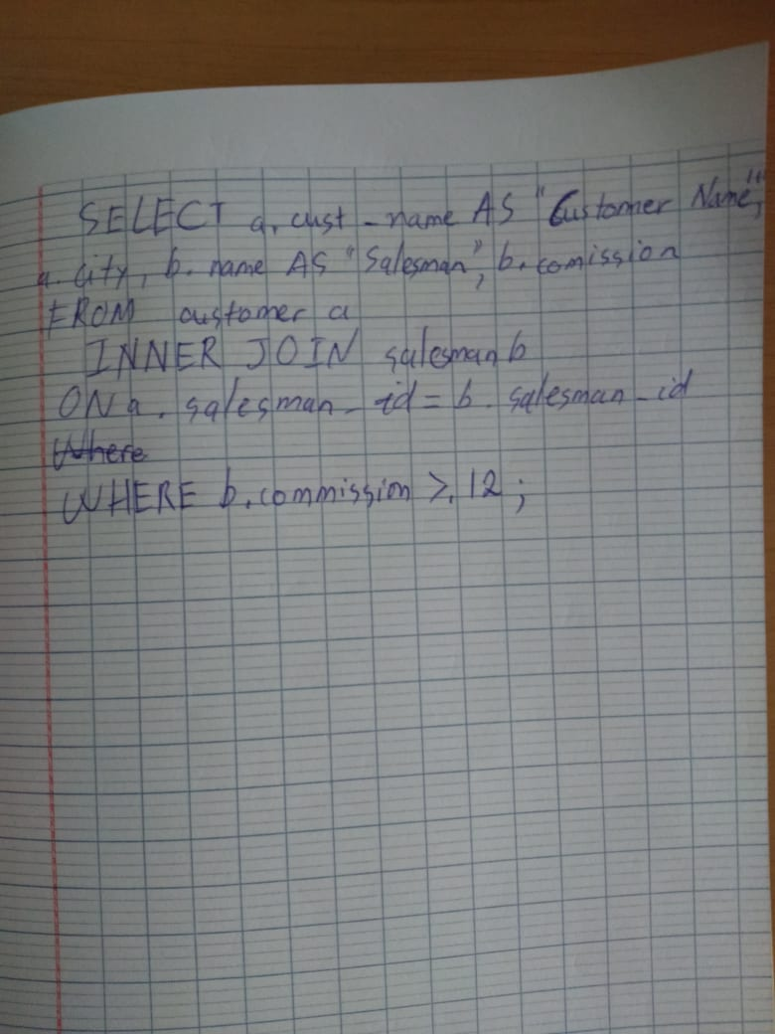

Câu 3a

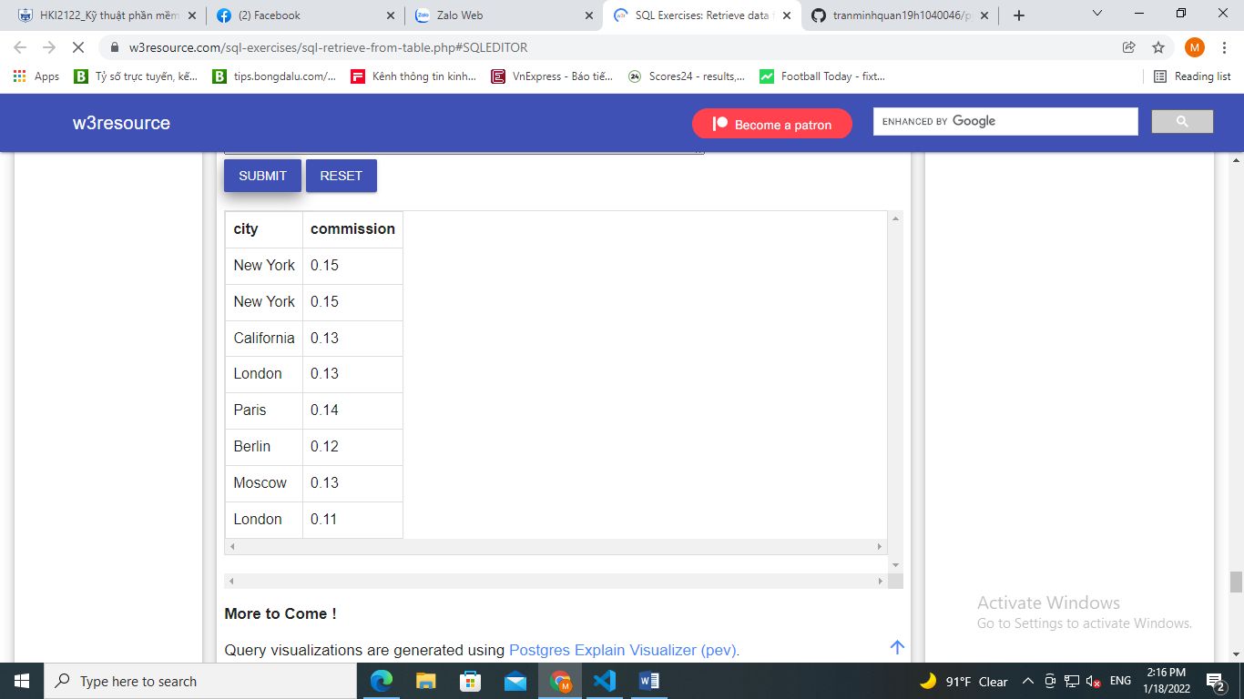

SELECT a.cust_name AS "city",

a.city, b.commission

FROM customer a

INNER JOIN salesman b

ON a.salesman_id=b.salesman_id

WHERE b.commission>.10;

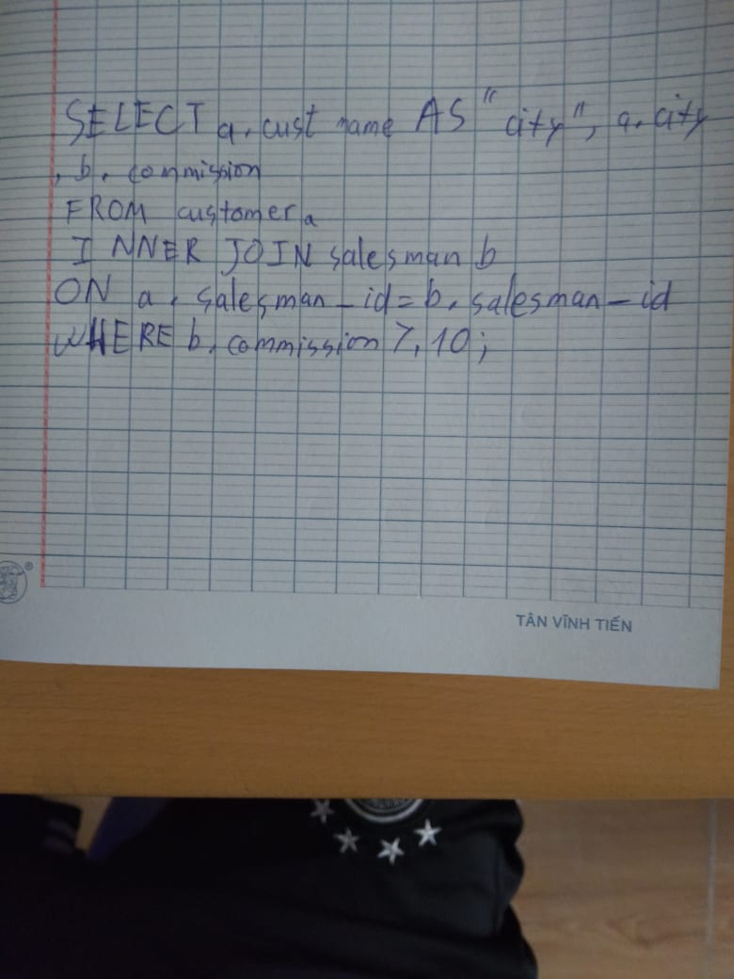

Câu 1 b

import pytest

def check_BCD_number(a):

    n = str(a)

    if n == '0000' or n == '0001' or n == '0010' or n == '0011' or n == '0100' or n == '0101' or n == '0110' or n == '0111' or n == '1000' or n == '1001':

        return True

    return False

@pytest.mark.parametrize("a ,check", [(1000, True), (1111, False), (211213, False)])

# Press the green button in the gutter to run the script.

def test_fnc(a, check):

    assert check == check_BCD_number(a)

